Configure AWS SNS, SQS, IAM, EC2, and CloudWatch CPU Alarm
EC2 INSTANCE
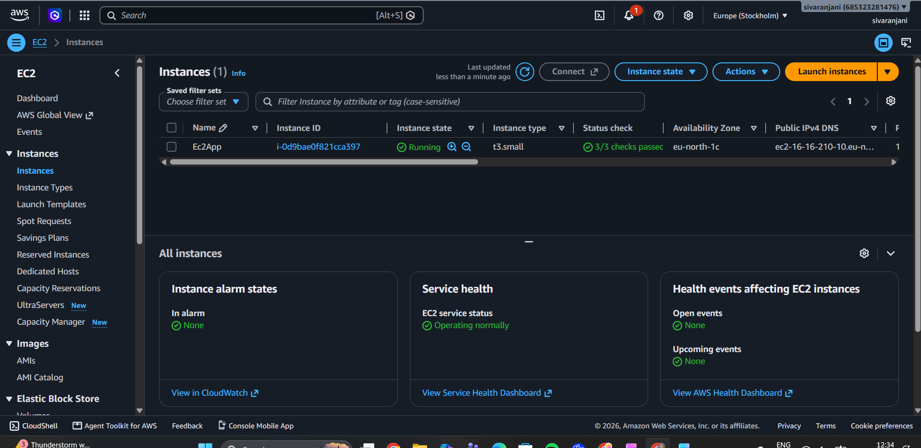
SNS TOPIC
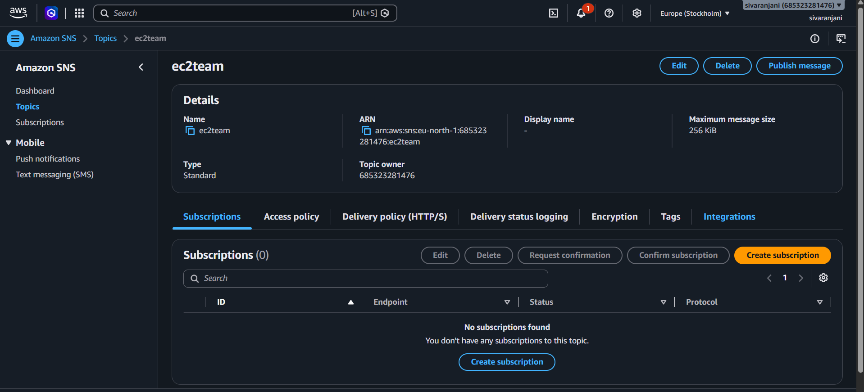

Email subscriber
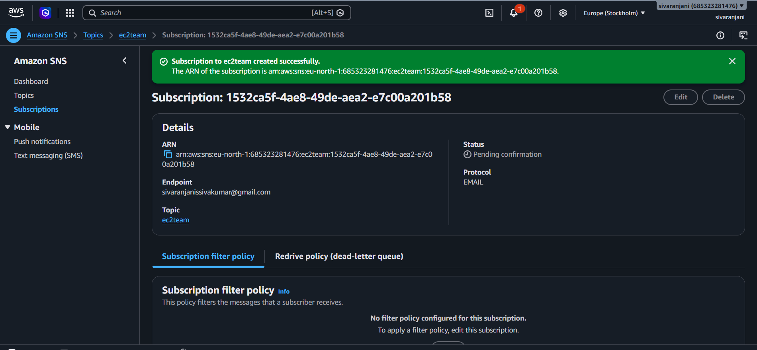
Sns-role for sqs subscriber
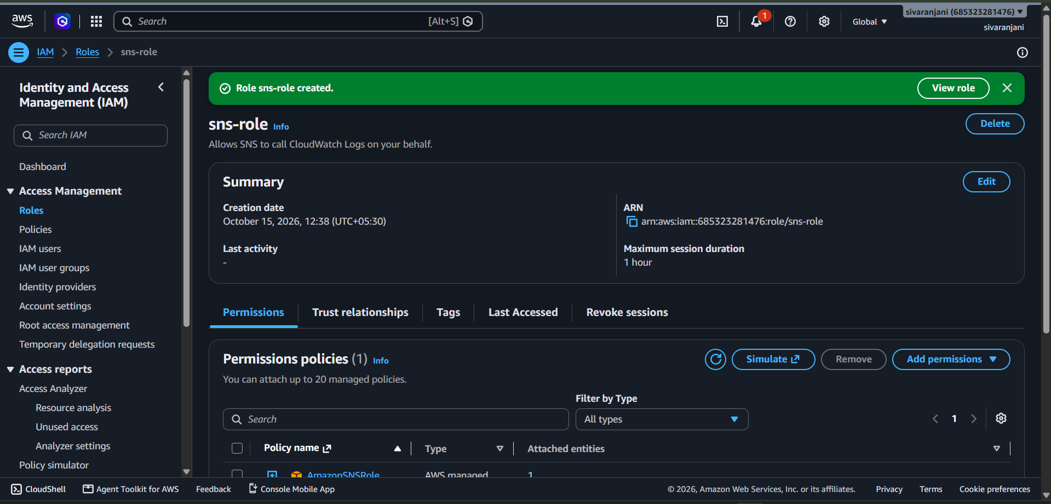
SQS EC2Manager
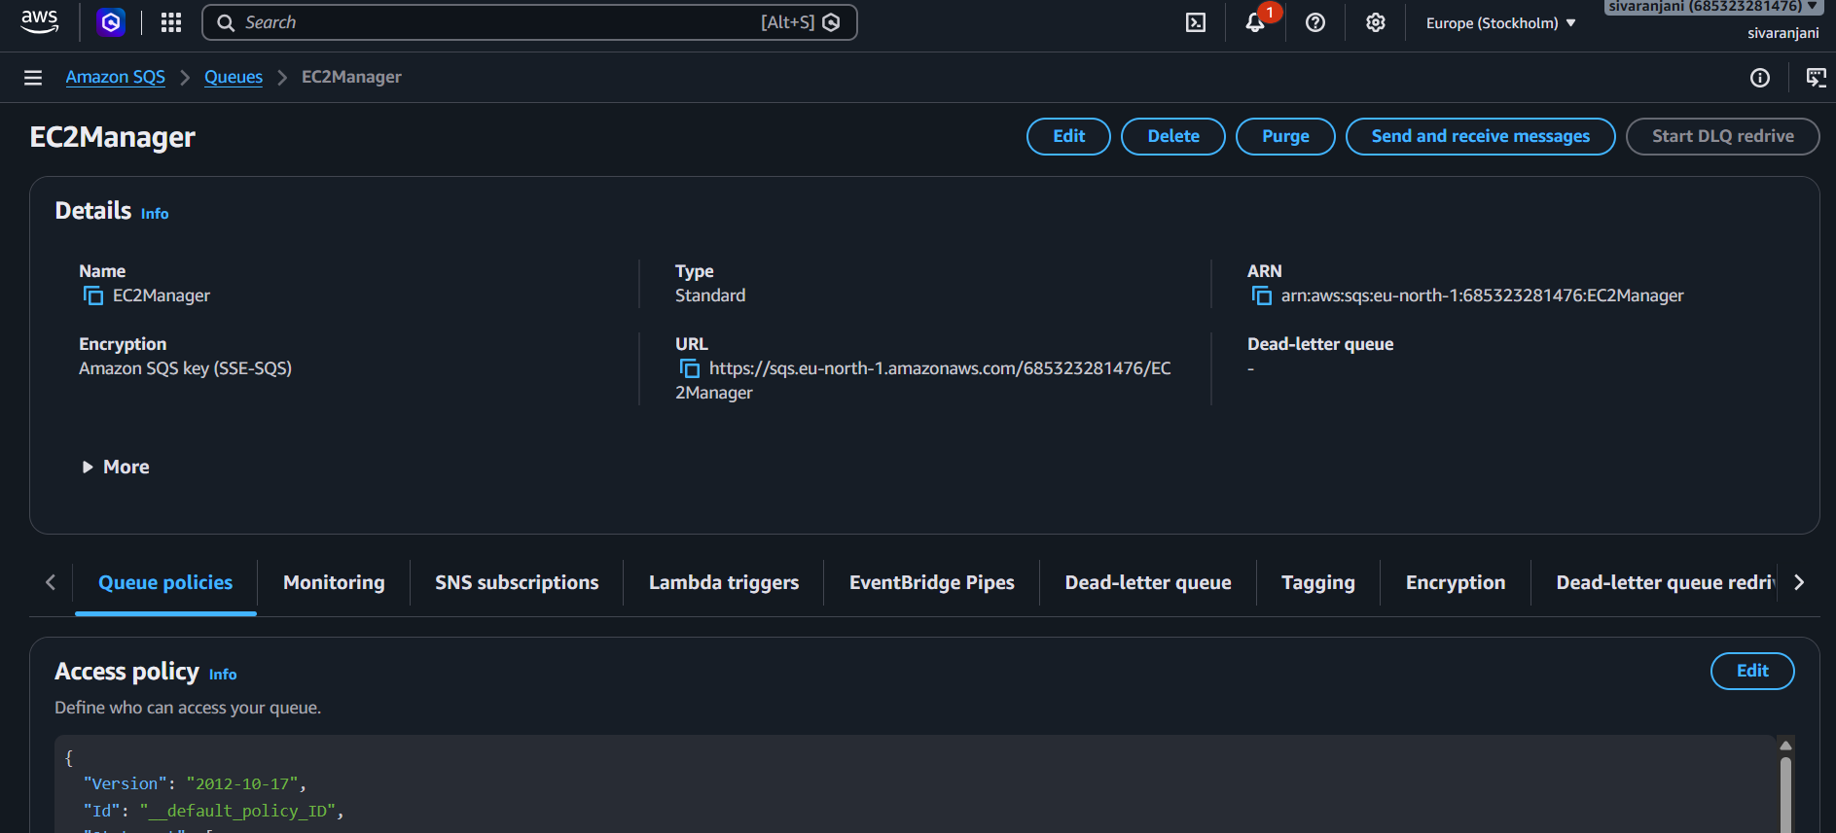
SUBSCRIBERS IN EC2TEAM SNS TOPIC
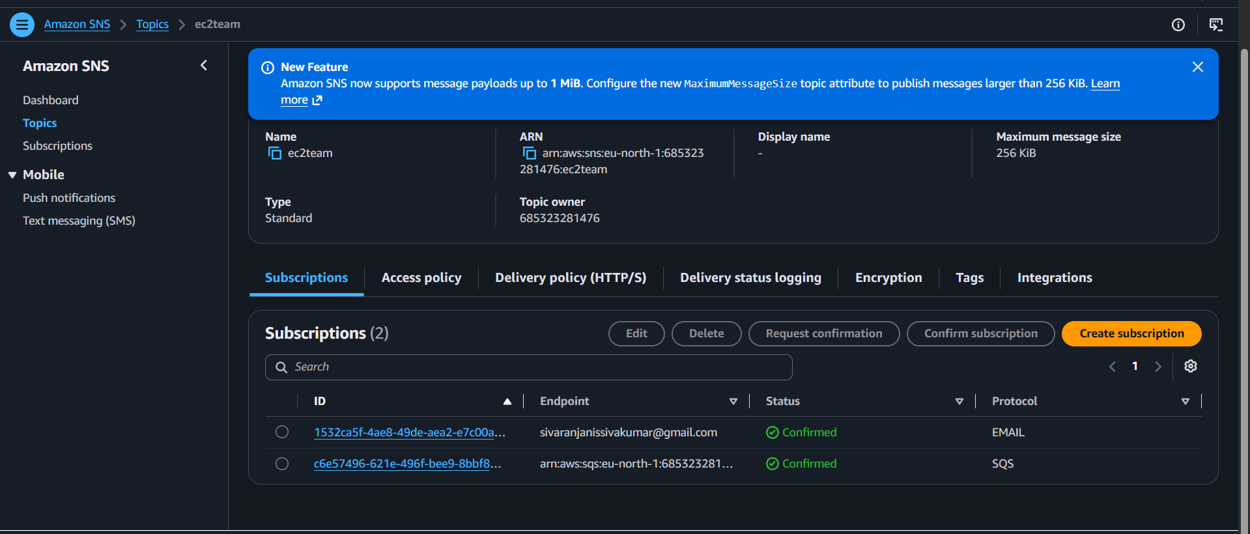
ALARM CREATED FOR THE CPU UTILIZATIONS
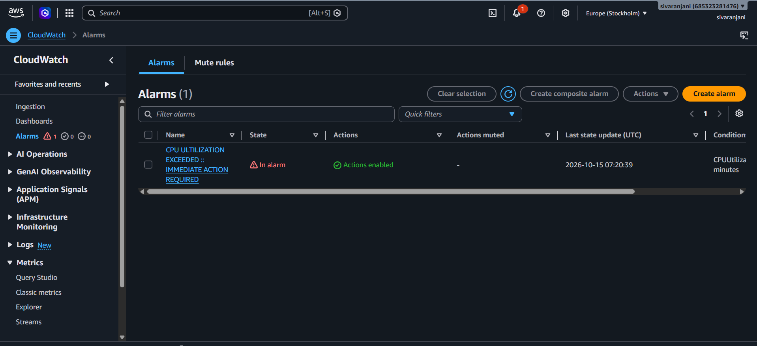
EMAIL SUBSCRIBER ALARM RECEIVED :
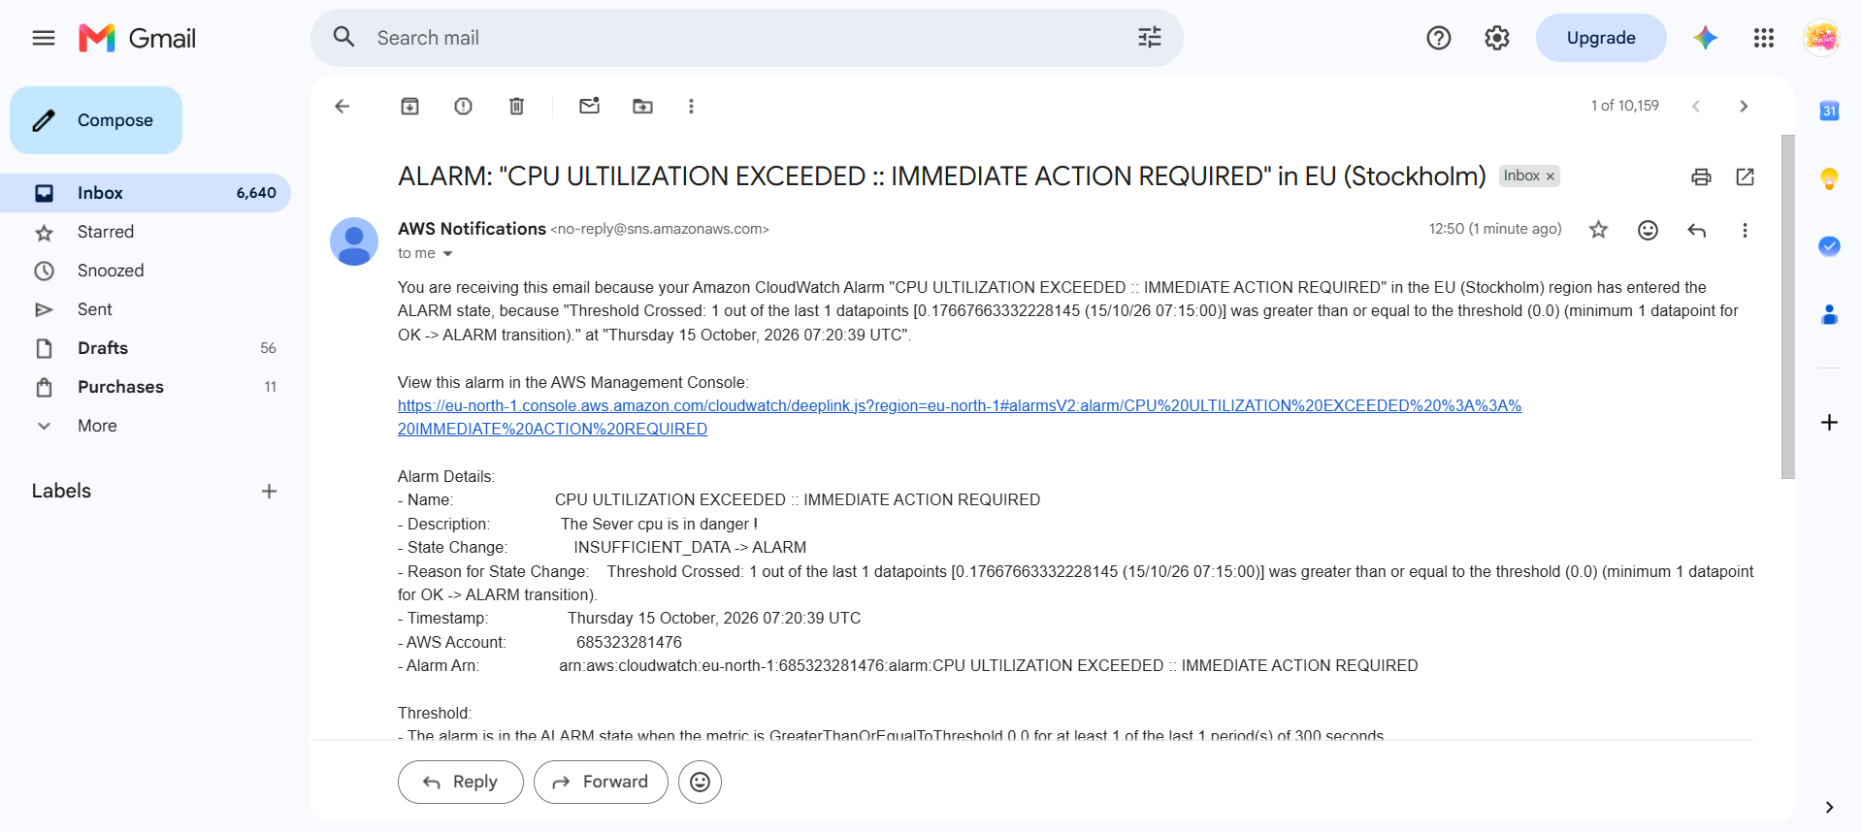
SQS MESSAGE received
